**Institute of Engineering & Management**

**Department of Computer Science & Engineering**

**Operating System Lab for 3rd year 6th semester 2019**

**Code: CS 693**

**Date:** 27/02/19

**WEEK-4**

**Assignment-1**

**Problem Statement:** Write a shell program to calculate the factorial of a number.

**Script:**

echo -e "\n\t----Factorial of a Number----\n"

read -p "Enter the number: " n

res=1

for x in `seq 1 $n`

do

res=`expr $res \* $x`

done

echo -e "\nFactorial of $n : $res\n\n"

**Screen-Shot:**

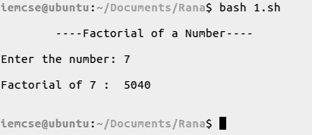

**Assignment-2**

**Problem Statement:** Write a shell menu driven program to do the following:

1. Display the current working directory.
2. Check whether an input number is even or odd.
3. Display the number of counts of all the files in the directory.
4. Print the long listing of all the files.

**Script:**

echo -e "\nPresent Working Directory: `pwd`\n\n"

read -p "Enter the number: " n

a=`expr $n % 2`

if [ n == 0 ]

then

echo -e "$a is Even\n\n"

else

echo -e "$a is Odd\n\n"

fi

a=`ls -p | grep -v "/$" | wc -w`

echo -e "Count of All the files: $a\n\n"

echo -e "Long listing of all files in current directory:"

ls -l -p | grep -v "/$"

echo -e "\n"

**Screen-Shot:**

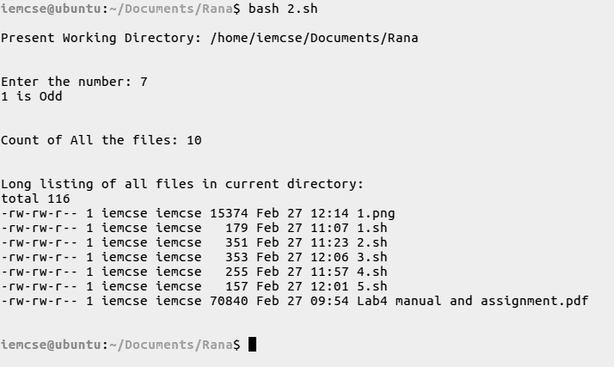

**Assignment-3**

**Problem Statement:** Write a shell program to display all the prime numbers between 1 to 100 using while loop.

**Script:**

echo -e "\n\t----Prime Numbers between 1 to 100----\n"

for x in `seq 2 100`

do

count=0

u=`echo "sqrt($x)" | bc`

for y in `seq 1 $u`

do

mod=`expr $x % $y`

if [ $mod == 0 ]

then

count=`expr $count + 1`

fi

done

if [ $count -lt 2 ]

then

echo -n "$x, "

fi

done

echo -e "\n"

**Screen-Shot:**

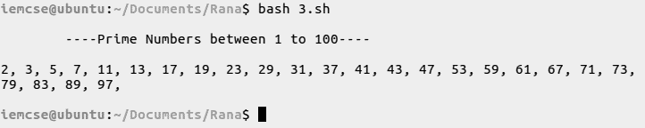

**Assignment-4**

**Problem Statement:** Write a menu program to find out whether a given letter is vowel or not.

**Script:**

echo -e "\n\t----Chencking Vowel----\n"

read -p "Enter a letter: " letter

vowels="a e i o u A E I O U"

con=`echo $vowels | grep -c $letter`

if [ $con == 1 ]

then

echo -e "\n$letter is a Vowel\n\n"

else

echo -e "\n$letter is a Consonent\n\n"

fi

**Screen-Shot:**

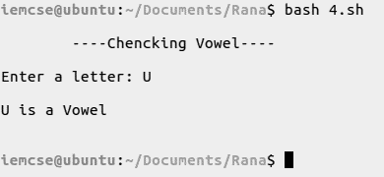

**Assignment-5**

**Problem Statement:** Write a shell script which will generate the output as follows:

*

* *

* * *

* * * *

**Script:**

echo -e "\n\t----Pattern----\n"

for i in `seq 1 4`

do

echo -ne "\t"

for j in `seq 1 $i`

do

echo -n "*"

done

echo -e "\n"

done

**Screen-Shot:**

